Max Petite
Built to Contain: Technology, Race, and Policy in Pruitt-Igoe
Public housing is one of those topics where people tend to start with the conclusion they already believe. If something succeeds, it becomes proof that government intervention works; if it fails, it becomes ammunition for the opposite claim. Pruitt-Igoe sits at the center of this dynamic. Built in the mid-1950s as part of St. Louis’s postwar redevelopment push, the Wendell O. Pruitt Homes and William Igoe Apartments (Pruitt-Igoe) were meant to replace a “substandard” landscape of overcrowded Black neighborhoods and stabilize land values around downtown (Gordon, 2009, p. 23). Instead, within two decades, the project became a national symbol of dysfunction, culminating in its televised demolition in the early 1970s. Suppose we consider Winner’s framing of technology as a system of power, labor, and governance, rather than as isolated objects (Winner, 1980). Pruitt-Igoe ends up looking a lot less like buildings collapsing and more like a technological disaster produced by the systems surrounding them.
These systems are easier to understand through Ruha Benjamin’s point that technoscientific systems often rely on “forms of containment that make innovation possible”, such that progress for some is built on the restricted mobility of others (Benjamin, 2016, p. 145). In St. Louis, the city’s redevelopment “innovation,” including new highways, downtown commercial growth, and suburban expansion, required confining Black residents to specific, designated spaces. Public housing was not simply built; it was routed through zoning battles, relocation bureaus, FHA lending rules, and a regional housing market that sorted people by race almost automatically. That sorting was not incidental. Benjamin calls this the “reasonableness of racism,” the way institutions reproduce hierarchy without anyone having to say so directly (p. 148). Pruitt-Igoe fits that logic almost too well. It became the designated endpoint for families displaced by urban renewal, held in place through bureaucratic containment: eligibility criteria, segregated relocation offices, and planning assumptions that treated North St. Louis as expendable (Bristol, 1991).
Seeing Pruitt-Igoe as a technological disaster means treating public housing itself as a technology: a system that organizes people, infrastructure, money, and state power into a predictable pattern. The consequences were concrete, not theoretical. As Gordon shows, clearance outpaced relocation; entire neighborhoods were demolished before alternative housing existed, forcing Black residents into the only units available (Gordon, 2009). Occupancy at Pruitt-Igoe plummeted within a few years, which mattered because the Housing Authority funded maintenance entirely through rent. With falling revenue, repairs simply stopped. Elevators broke and stayed broken. Buildings became dangerous because vandalism went unrepaired. Windows failed, heating systems deteriorated, and the project’s reputation spiraled downward. By the late 1960s, the buildings were in a state of physical collapse, and the city had largely abandoned them.
This is where Bristol becomes essential. The famous story of Pruitt-Igoe is that it collapsed because its “High Modernist” design was naive or architecturally arrogant; however, this explanation works only if the context is stripped away. Bristol shows that this story was a myth created after the fact, one that conveniently masked the real causes: systematic underfunding, political hostility to public housing, federal cost-cutting that forced low-quality materials, and the racialized assumptions that made neglect seem natural (Bristol, 1991). By the time the first demolition charges went off in 1972, the disaster had already occurred; the implosions were merely the visible culmination of a slow-motion collapse engineered by policy.
Seeing Pruitt-Igoe through the lens of Benjamin, Gordon, and Bristol makes the disaster legible as a system rather than a set of buildings, but those accounts all come from a retrospective vantage point. What they cannot show is how the project felt and was understood while it was still operating, before the demolition footage turned it into a symbol. To get that perspective, I turned to a 1970 New York Times article by James Naughton titled “Urban Malaise Grips Penthouse and Slum,” which I accessed through the TimesMachine archive. I chose it because it fills in the narrative gaps that academic accounts cannot: it captures how Pruitt-Igoe appeared to outsiders at the exact moment the system was breaking down. Naughton was one of the NYT’s White House and national correspondents, and in this case, part of a four-journalist “national cities tour,” which already tells me something about the framing. He is not a St. Louis local, a housing scholar, or embedded in the neighborhood; he is a visiting reporter writing for a national audience that already thinks it understands what “urban crisis” means. The piece fits within that frame. It is structured as a cross-city diagnosis of despair—Seattle, San Antonio, Birmingham, Detroit, Philadelphia—and then suddenly drops the reader into the middle of Pruitt-Igoe as the physical evidence of a broader national abandonment.
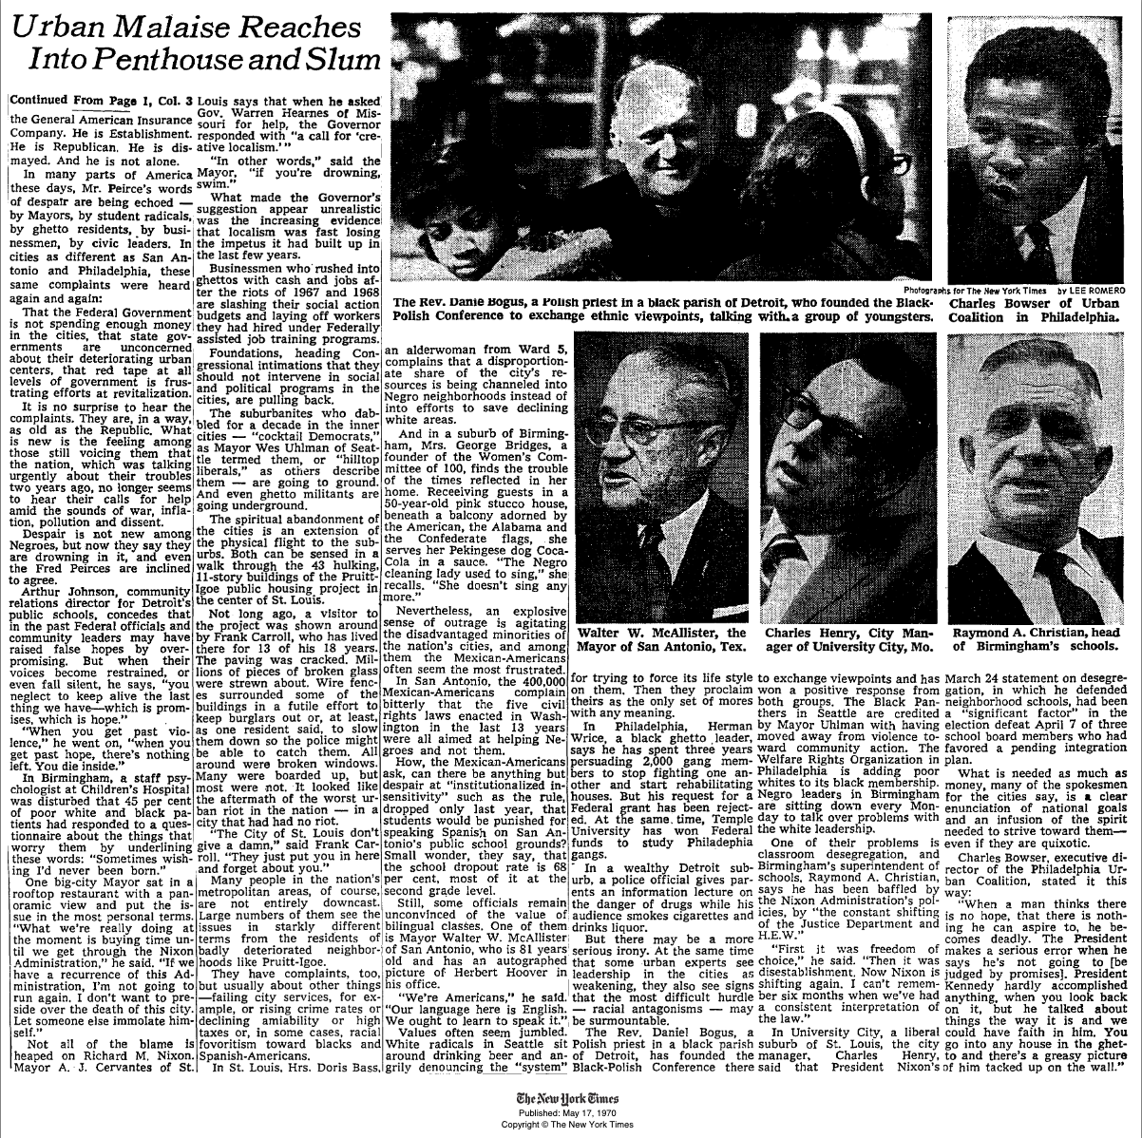
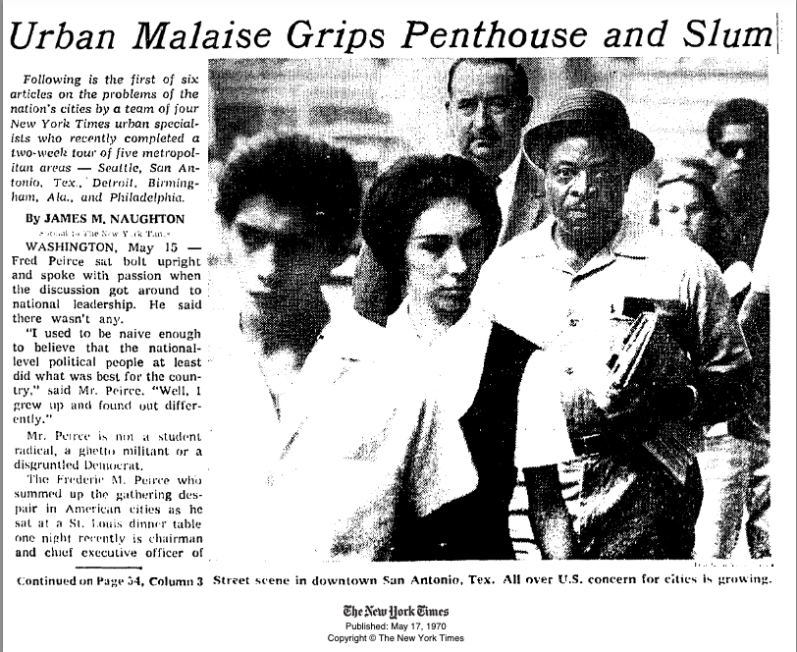
The St. Louis section is reported almost entirely through what Naughton sees and what residents tell him. There are no charts or maps, just descriptive imagery and quotes. He describes walking among “the 43 hulking, 11-story buildings” and says the grounds looked “like the aftermath of the worst urban riot in the nation—in a city that had had no riot” (Naughton, 1970). The most quoted resident, Frank Carroll, offers the line that keeps showing up in later retellings: “The City of St. Louis do not give a damn… They just put you in here and forget about you” (Naughton, 1970). The visual language of “cracked paving,” “millions of pieces of broken glass,” boarded windows, and wire fencing, meant to slow burglars rather than stop them, is doing the work that statistics normally do in a policy report (Naughton, 1970). The article is not subtle about the emotional stakes; it places Pruitt-Igoe as the material symptom of a broader collapse in political will, then juxtaposes that with complaints from white suburbanites who are more concerned about taxes or the “declining amiability” of city life (Naughton, 1970).
As an artifact, the text feels split. It is observational journalism, but it is also an interpretive object: the way Naughton writes turns Pruitt-Igoe into shorthand for national decline. Even the placement: front-page, long-form, framed as the “first of six articles”, tells me this was not treated as a local St. Louis housing-management issue. It was presented as evidence of something systemic, even if the article never directly names the policies that produced those conditions. That silence is part of why I chose it.
However, that silence does not equal superficiality. Even without naming policy, the article reveals more structural insight than I initially assumed. I expected to find a familiar form of national reporting that drops into a “slum,” extracts a few shocking visuals, and leaves the structural context behind. However, Naughton’s piece is more complicated. He does adopt the crisis language of the era: “urban malaise,” “despair,” and the sense of a country losing faith in its cities, but he also exposes the political scaffolding around that despair. The article shifts between elites and residents, but it continually returns to the idea that the crisis is not just emotional or aesthetic; it is a governmental issue. Mayors talk about federal abandonment, state indifference, and the consequences of “creative localism,” and the article puts that governmental failure in the same frame as Pruitt-Igoe’s physical deterioration. The implication is not subtle: the conditions Naughton walks through are tied to choices made far above the people living in the project.

This is precisely what Winner means when he says artifacts have politics: technologies are not neutral; they “order human activity” in ways shaped by the political arrangements that produce them (Winner, 1980, p. 127). Naughton’s descriptions of broken elevators, exposed stairwells, and fenced-off grounds make those arrangements visible; they are the physical consequences of governance decisions, such as funding cuts, segregationist siting, and maintenance starvation. Benjamin’s framework deepens that reading. Her idea that technoscientific systems rely on “forms of containment” and the “reasonableness of racism” helps explain why these failures were concentrated in places like Pruitt-Igoe (Benjamin, 2016, pp. 145, 148). Residents’ comments, such as “They just put you in here and forget about you,” express the lived experience of that containment (Naughton, 1970). Read together, Winner and Benjamin show how Naughton’s account turns the project’s physical deterioration into evidence of a system that utilized the built environment itself to enforce racialized containment.

What I see, then, is a text that reveals both the materiality and discursivity of technological disaster. It documents the lived experience of residents within a failing system, while simultaneously employing national political rhetoric to explain why that failure feels unsurprising. The article becomes an archive of how Pruitt-Igoe was understood before its demolition made it a symbol of urban decay. It captures the convergence of federal retreat, urban renewal, racialized containment, and infrastructural neglect, which are precisely the dynamics Gordon and Benjamin describe, while also participating in the broader national conversation about whether cities were governable at all. In this sense, the text sits at the intersection of culture, society, science, and technology, treating Pruitt-Igoe not as an isolated problem but as a material sign of a political system that had already begun to abandon the very communities it claimed to be built for.
If I were to expand this into a longer paper, the first thing I would want to understand is how Naughton’s article circulated and whether it influenced any policy discussions. The piece clearly framed Pruitt-Igoe as evidence of national “urban crisis,” but I am unsure if readers, St. Louis officials, or federal housing staff interpreted it as a warning, a confirmation of existing biases, or just another spectacle of urban decay. That reception matters because it would tell me whether the article reinforced the myths Bristol describes or whether it offered any opening for structural critique.
I would also want to know more about whose voices are absent. Naughton quotes residents, but not tenant leaders, community organizers, or anyone inside the Housing Authority who was dealing with the budget crisis Gordon describes. Understanding what those groups were saying at the same moment would help me gauge whether the article captured the political stakes of 1970 or filtered them through a familiar national storyline.
There is also a political context the article hints at but does not explain: HUD funding cuts, stalled regional integration, internal maintenance records, and decisions about which buildings to close first. Knowing more about those pressures would let me see how the conditions Naughton observed were being produced in real time, not just witnessed.
To answer these questions, I would look at local newspapers, city archives, HUD documents, and other Times pieces from the same series. That would allow me to read the article not just as a description of Pruitt-Igoe, but as part of the machinery that shaped how Americans understood public housing while it was falling apart.

References
Benjamin, R. (2016). Catching our breath: Critical race STS and the carceral imagination. Engaging Science, Technology, and Society, 2, 145–156. https://doi.org/10.17351/ests2016.70
Bristol, K. G. (1991). The Pruitt-Igoe myth. Journal of Architectural Education, 44(3), 163–171.
Gordon, C. (2009). Mapping Decline: St. Louis and the Fate of the American City. University of Pennsylvania Press.
Naughton, J. M. (1970, May 15). Urban malaise grips the penthouse and slum. https://timesmachine.nytimes.com/timesmachine/1970/05/17/354943772.html?pageNumber=1
Winner, L. (1980). Do artifacts have politics? Daedalus, 109(1), 121–136. https://www.jstor.org/stable/20024652
Grammarly. (2025). Grammarly writing assistance tool. https://www.grammarly.com/
Used for proofreading.
OpenAI. (2025). ChatGPT (GPT-5). https://chat.openai.com/
Used for preliminary source finding.

